**Search for the most common cloud providers:**

1. Amazon Web Services (AWS)
2. Microsoft Azure
3. Google Cloud
4. Alibaba Cloud
5. IBM Cloud
6. Oracle
7. Salesforce
8. SAP
9. Rackspace Cloud
10. VMWare

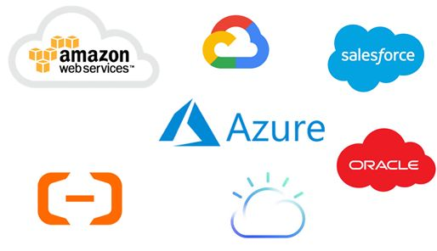

**The best use case of each cloud providers:**

1. **AWS Services**

AWS offers hundreds of services. Some of these include Virtual Private Cloud, EC2, AWS Data Transfer, Simple Storage Service, DynamoDB, Elastic Compute Cloud, AWS Key Management Service, AmazonCloudWatch, Simple Notification Service, Relational Database Service, Route 53, Simple Queue Service, CloudTrail, and Simple Email Service.

The following graphic is a list of the various categories of services available in AWS. The right side of the list includes AWS’s featured services.

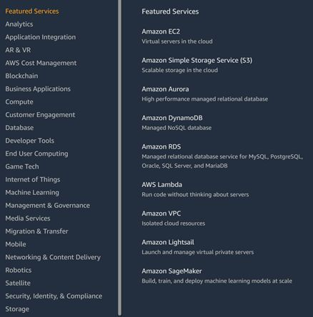

1. **Microsoft Azure :**

Azure offers hundreds of services within various categories including AI + Machine Learning, Analytics, Blockchain, Compute, Containers, Databases, Developer Tools, DevOps, Identity, Integration, Internet of Things, Management, Media, Microsoft Azure Stack, Migration, Mixed Reality, Mobile, Networking, Security, Storage, Web, and Windows Virtual Desktop.

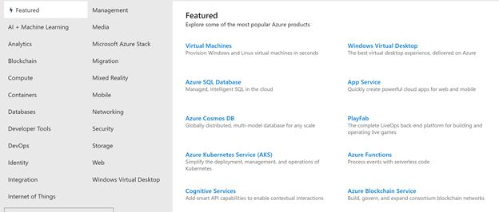

1. **IBM Cloud :**

IBM Cloud developed by IBM is a set of cloud computing services for businesses. Similar to other cloud service providers, the IBM cloud includes IaaS, SaaS, and PaaS services via public, private, and hybrid cloud models.

Compute, Network, Storage, Cloud Packs, Management, Security, Database, Analytics, AI, IoT, Mobile, Dev Tools, Blockchain, Integration, Migration, Private Cloud, and VMware.

1. **Google Cloud:**

AI and Machine Learning, API Management, Compute, Containers, Data Analytics, Databases, Developer Tools, Healthcare and Life Sciences, Hybrid and Multi-cloud, Internet of Things, Management Tools, Media and Gaming, Migration, Networking, Security and Identity, Serverless Computing, and Storage.

Google products are also offered in the cloud, including G Suite, Google Maps Platform, Google Hardware, Google Identity, Chrome Enterprise, Android Enterprise, Apigee, Firebase, and Orbitera.

1. **Oracle Cloud:**

Oracle IaaS offerings are Compute, Storage, Networking, Governance, Database, Load Balancing, DNS Monitoring, Ravello, and FastConnect.

Oracle PaaS offerings are Data Management, Application Development, Integration, Business Analytics, Security, Management, and Content and Enterprise.

Oracle SaaS offerings are CX, HCM, ERP, SCM, EPM, IoT, Analytics, Data, and Blockchain Applications.

Oracle DaaS is the Oracle Data Cloud.

1. **Alibaba Cloud:**

Alibaba offers various products and services in various categories, including Elastic Computing, Storage and CDN, Networking, Database Services, Security, Monitoring and Management, Domains and Websites, Analytics and Data Technology, Application Services, Media Services, Middleware, Cloud Communication, Apsara Stack, and Internet of Things.